DAFTAR ISI

A. IDENTITAS 2
B. HASIL PRAKTIKUM/ TUGAS 2
1. Modul 10_02 Praktikum 2
a. Kode program 2
b. Hasil Run 11
2. Modul 10_03 Praktikum 11
a. Kode Program 11
b. Hasil Run 15
3. Modul 10_03 Latihan 17
a. Kode Program 17
b. Hasil Run 26
4. Modul 11 Praktikum 26
a. Panel Dashboard 26
b. Hasil Run 28
c. Panel Kategori 28
d. Hasil Run 29
e. Panel Produk 29
f. Hasil Run 30
g. Panel Satuan 31
h. Hasil Run 32
i. Panel Supplier 32
j. Hasil Run 33
k. Frame Utama 33
l. Dashboard App 36
5. Modul 10_03 Tugas 36
a. Kode program 36
b. Hasil Run 45
6. Pengalaman Pembelajaran 46

IDENTITAS
NIM : 2403001
Nama Lengkap : Siti Sa’adah
Kelas : D3 TI 2A
Program Studi : D3 TEKNIK INFORMATIKA
Jurusan : TEKNIK INFORMATIKA

HASIL PRAKTIKUM/ TUGAS
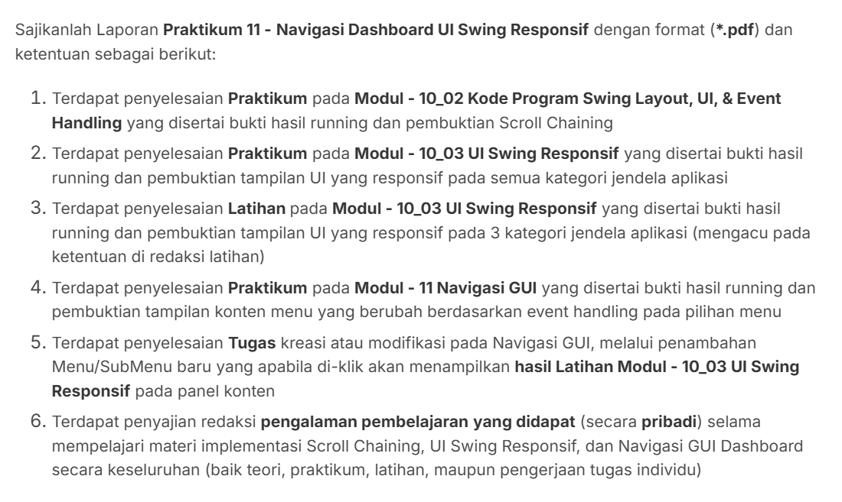

Modul 10_02 Praktikum

Kode program
import java.awt.*;
import java.awt.event.*;
import javax.swing.*;
import javax.swing.border.TitledBorder;
import javax.swing.table.DefaultTableModel;
import net.miginfocom.swing.MigLayout;
import com.formdev.flatlaf.FlatLaf;
import com.formdev.flatlaf.FlatLightLaf;

import java.util.Collections;

public class RenovationApp {

private static String buttonColor = "background: $Component.accentColor; foreground: #FFFFFF;";

public static void main(String[] args) {

try {
FlatLaf.setGlobalExtraDefaults(Collections.singletonMap("@accentColor", "#8A2BE2"));
UIManager.setLookAndFeel(new FlatLightLaf());
} catch (Exception e) {
try {
UIManager.setLookAndFeel(UIManager.getSystemLookAndFeelClassName());
} catch (Exception ex) {
}
}

SwingUtilities.invokeLater(() -> {

/** Deklarasi Frame **/
JFrame frame = new JFrame("Detail Proyek: RNV–JKT–AXG–001");
frame.setDefaultCloseOperation(JFrame.EXIT_ON_CLOSE);
frame.setPreferredSize(new Dimension(1024, 768));
frame.setMinimumSize(new Dimension(800, 600));

/** Deklarasi Panel Utama **/
JPanel panelUtama = new JPanel(new MigLayout(
"fill, wrap 3",
"[][grow][]",
"[][grow][grow][grow][]"
));

/** Deklarasi Panel Information **/
JPanel panelInformation = new JPanel(new MigLayout(
"wrap 3",
"[right]10[left, grow, fill]5[fill]"
));
panelInformation.setBorder(new TitledBorder("Information"));

panelInformation.add(new JLabel("Reserve days:"));
panelInformation.add(new JTextField("0 of 30"));
panelInformation.add(new JButton("Add Days"));

panelInformation.add(new JLabel("Buyer:"));
panelInformation.add(new JTextField("Bapak Alex Gunawan"), "span 2");

panelInformation.add(new JLabel("Seller:"));
panelInformation.add(new JTextField("PT Bangun Jaya Abadi"), "span 2");

panelInformation.add(new JLabel("Address:"));
panelInformation.add(new JTextField("Jl. Raya Lohbener Baru, 778A"), "span 2");

panelInformation.add(new JLabel("Credit rating:"));
panelInformation.add(new JTextField("AAA"));

panelInformation.add(new JLabel("Update:"));
panelInformation.add(new JButton("S&P Update"));

panelInformation.add(new JCheckBox("Approved:"));

panelInformation.add(new JLabel("Note:"));
panelInformation.add(new JTextField("Proyek renovasi telah disetujui, siap dimulai"), "span 2");

/** Deklarasi Panel Client **/
JPanel panelClient = new JPanel(new MigLayout(
"wrap 2",
"[right]10[left]"
));
panelClient.setBorder(new TitledBorder("Client"));

panelClient.add(new JLabel("Client ID:"));
panelClient.add(new JLabel("<html><b>101</b></html>"));

panelClient.add(new JLabel("Name:"));
panelClient.add(new JLabel("<html><b>Bapak Alex Gunawan</b></html>"));

panelClient.add(new JLabel("Phone:"));
panelClient.add(new JLabel("<html><b>(+62) 8123456789</b></html>"));

panelClient.add(new JLabel("Registration No:"));
panelClient.add(new JLabel("<html><b>RNV–JKT–AXG–001</b></html>"));

JButton buttonDetails = new JButton("Details");
buttonDetails.putClientProperty("FlatLaf.style", buttonColor);
panelClient.add(buttonDetails, "span 2, center");

panelUtama.add(panelClient, "grow");

panelUtama.add(panelInformation, "grow");

/** Deklarasi Panel Additional Information **/
JPanel panelAdditional = new JPanel(new MigLayout("wrap 3", "[right]10[left,grow,fill][]"));
panelAdditional.setBorder(new TitledBorder("Additional Information"));

panelAdditional.add(new JLabel("Estimated close:"));
panelAdditional.add(new JTextField("2025-12-15"), "wmin pref");
panelAdditional.add(new JButton("Edit"), "wmax pref");

panelAdditional.add(new JLabel("Creation date:"));
panelAdditional.add(new JLabel("<html><b>2025-10-15</b></html>"), "span 2");

panelAdditional.add(new JLabel("Created by:"));
panelAdditional.add(new JLabel("<html><b>Admin</b></html>"), "span 2");

panelAdditional.add(new JLabel("Last edit date:"));
panelAdditional.add(new JLabel("<html><b>2025-11-16</b></html>"), "span 2");

panelAdditional.add(new JLabel("Last edited by:"));
panelAdditional.add(new JLabel("<html><b>Warnoto</b></html>"), "span 2");

panelAdditional.add(new JLabel("Closed date:"));
panelAdditional.add(new JLabel("<html><b>null</b></html>"), "span 2");

panelAdditional.add(new JLabel("Closed by:"));
panelAdditional.add(new JLabel("<html><b>null</b></html>"), "span 2");

panelUtama.add(panelAdditional, "grow");

/** Deklarasi Panel Product List **/
JPanel panelProduk = new JPanel(new MigLayout("", "[grow][]"));
panelProduk.setBorder(new TitledBorder("Product List"));

/** Deklarasi Panel (Table) Product List **/
JPanel panelTableProductList = new JPanel(new MigLayout("wrap 3", "[grow][left][right]", "[][ ][][ ]"));

String[] kolomTableProductList = {
"Renovation", "Description", "Part #", "Quantity", "List Price",
"Discount", "Price", "Wholesale Discount", "Wholesaler Price"
};

Object[][] dataProductList = {
{ "Dapur", "Keramik Dinding Putih", "KW-PT-DLX-01", 50, 150000, 0, 7500000L, 5, 712500L },
{ "Dapur", "Lem Keramik Instan", "MLR-GRY-STD", 5, 50000, 0, 250000L, 0, 250000L },
{ "Dapur", "Pipa PVC 3 inch", "PVC-3IN-STOD", 12, 35000, 0, 420000L, 10, 378000L },
{ "Kamar Mandi", "Shower Set Minimalis", "SHW-MN-STL", 1, 850000, 15, 722500L, 5, 686375L },
{ "Kamar Mandi", "Closet Duduk Premium", "CLO-DD-PRM", 1, 2500000, 5, 2375000L, 10, 2137500L },
{ "Ruang Tamu", "Lampu Gantung Hias", "LMP-MNG-CRS", 2, 750000, 0, 1500000L, 0, 1500000L },
{ "Ruang Tamu", "Cat Tembok Putih 20L", "CAT-PT-20L", 3, 450000, 10, 1215000L, 15, 1032750L },
{ "Garasi", "Semen PC 50Kg", "SMN-PC-50", 20, 60000, 0, 1200000L, 5, 1140000L },
};

DefaultTableModel tableModelProductList = new DefaultTableModel(dataProductList, kolomTableProductList);
JTable tableProductList = new JTable(tableModelProductList);
tableProductList.setAutoCreateRowSorter(true);
tableProductList.setShowGrid(true);

JScrollPane scrollPaneTableProductList = new JScrollPane(tableProductList);
panelTableProductList.add(scrollPaneTableProductList, "span 3, growx, h 150");

panelTableProductList.add(new JSeparator(), "growx");
panelTableProductList.add(new JLabel("Subtotal list price:"), "gapx 10");
panelTableProductList.add(new JLabel("Rp 15.570.000"), "gapx 30");

panelTableProductList.add(new JLabel("Total retailer price:"), "skip 1, gapx 10");
panelTableProductList.add(new JLabel("Rp 15.182.500"), "gapx 30");

panelTableProductList.add(new JLabel("Total wholesaler price:"), "skip 1, gapx 10");
panelTableProductList.add(new JLabel("Rp 14.249.625"), "gapx 30");

panelProduk.add(panelTableProductList, "grow");

/** Deklarasi Panel (Button) Product List **/
JPanel panelButtonProductList = new JPanel(new MigLayout("wrap 1"));

panelButtonProductList.add(new JButton("Add"));
panelButtonProductList.add(new JButton("Edit"));
panelButtonProductList.add(new JButton("Delete"));

panelProduk.add(panelButtonProductList, "grow");
panelUtama.add(panelProduk, "growx, span 3");

/** Deklarasi Panel Tasks **/
JPanel panelTask = new JPanel(new MigLayout("", "[grow][]"));
panelTask.setBorder(new TitledBorder("Tasks"));

String[] kolomTableTask = {
"State", "Task", "Assigner", "Executer",
"Creation Date", "Estimated Date", "Executed Date"
};

Object[][] dataTask = {
{ "Completed", "Pengecatan ulang ruang tamu", "Warnoto", "Toni", "2025-10-25", "2025-10-28", "2025-10-27" },
{ "In Progress", "Instalasi closet duduk premium", "Warnoto", "Goang", "2025-11-15", "2025-11-17", null },
{ "Delayed", "Pemasangan keramik dinding dapur", "Warnoto", "Toni", "2025-11-01", "2025-11-04", null },
{ "Completed", "Pemasangan pipa PVC di area garasi", "Warnoto", "Goang", "2025-10-20", "2025-10-21", "2025-10-21" },
{ "Not Started", "Pembelian dan instalasi lampu gantung hias", "Warnoto", "Toni", "2025-11-16", "2025-11-18", null }
};

DefaultTableModel tableModelTask = new DefaultTableModel(dataTask, kolomTableTask);
JTable tableTask = new JTable(tableModelTask);
tableTask.setAutoCreateRowSorter(true);
tableTask.setShowGrid(true);

JScrollPane scrollPaneTableTask = new JScrollPane(tableTask);
panelTask.add(scrollPaneTableTask, "grow, hmin 150, hmax 190");

/** Deklarasi Panel Controls */
JPanel panelControls = new JPanel(new MigLayout("insets 0", "[grow,left][right]"));

/** Deklarasi Panel Controls (Left) */
JPanel panelControlsLeft = new JPanel(new MigLayout());
panelControlsLeft.add(new JButton("Export"));
panelControls.add(panelControlsLeft);

/** Deklarasi Panel (Button) Tasks */
JPanel panelButtonTask = new JPanel(new MigLayout("wrap 1"));
panelButtonTask.add(new JButton("Add"));
panelButtonTask.add(new JButton("Edit"));
panelButtonTask.add(new JButton("Delete"));
panelTask.add(panelButtonTask, "grow");
panelUtama.add(panelTask, "grow, span 3");

/** Deklarasi Panel Comments */
JPanel panelComments = new JPanel(new MigLayout("", "[grow][]"));
panelComments.setBorder(new TitledBorder("Comments"));

String[] kolomTableComment = { "Date", "User", "Comment" };

Object[][] dataComment = {
{ "2025-10-26 10:15", "Toni", "Cat tembok sudah diolesi lapisan pertama. Menunggu kering sebelum lapisan kedua." },
{ "2025-11-15 14:30", "Goang", "Barang sudah sampai di lokasi. Mulai proses pembongkaran closet lama sore ini." },
{ "2025-11-16 09:00", "Warnoto", "Pastikan sambungan pipa air bersih dan pembuangan tidak ada yang bocor, cek tekanannya." },
{ "2025-11-03 16:45", "Toni", "Cuaca hujan deras selama 2 hari, area kerja sedikit basah. Pemasangan ditunda besok pagi." },
{ "2025-11-16 20:00", "Warnoto", "Lampu yang diinginkan customer stoknya habis. Mencari alternatif lampu model serupa." },
};

DefaultTableModel tableModelComment = new DefaultTableModel(dataComment, kolomTableComment);
JTable tableComment = new JTable(tableModelComment);
tableComment.setAutoCreateRowSorter(true);
tableComment.setShowGrid(true);

JScrollPane scrollPaneTableComment = new JScrollPane(tableComment);
panelComments.add(scrollPaneTableComment, "grow, hmin 150, hmax 190");

/** Deklarasi Panel (Button) Comments */
JPanel panelButtonComment = new JPanel(new MigLayout("wrap 1"));
panelButtonComment.add(new JButton("Add"));
panelButtonComment.add(new JButton("Edit"));
panelButtonComment.add(new JButton("Delete"));
panelComments.add(panelButtonComment, "grow");
panelUtama.add(panelComments, "grow, span 3");

/** Deklarasi ScrollPane **/
JScrollPane scrollPane = new JScrollPane(panelUtama);
scrollPane.getVerticalScrollBar().setUnitIncrement(18);
scrollPane.getVerticalScrollBar().putClientProperty("JScrollBar.fastWheelScrolling", true);
scrollPane.putClientProperty("JScrollPane.fastWheelScrolling", true);
scrollPane.setVerticalScrollBarPolicy(JScrollPane.VERTICAL_SCROLLBAR_AS_NEEDED);

frame.add(scrollPane);
frame.pack();
frame.setLocationRelativeTo(null);
frame.setVisible(true);

installModernScrollChaining(frame, scrollPane);

/** Deklarasi Panel Controls (Right) */
JPanel panelControlsRight = new JPanel(new MigLayout());
JButton buttonSave = new JButton("Save");
buttonSave.putClientProperty("FlatLaf.style", buttonColor);
panelControlsRight.add(buttonSave);
panelControlsRight.add(new JButton("Cancel"));
panelControls.add(panelControlsRight);
panelUtama.add(panelControls, "grow, span 3");
});
}

private static void installModernScrollChaining(JFrame frame, JScrollPane mainScrollPane) {
final double[] accumulatedDelta = {0.0};

Toolkit.getDefaultToolkit().addAWTEventListener(event -> {
if (!(event instanceof MouseWheelEvent)) return;
MouseWheelEvent mwe = (MouseWheelEvent) event;
if (mwe.isConsumed()) return;

Component source = mwe.getComponent();
if (!SwingUtilities.isDescendingFrom(source, frame)) return;

JScrollPane inner = null;
for (Component c = source; c != null; c = c.getParent()) {
if (c instanceof JScrollPane) {
JScrollPane sp = (JScrollPane) c;
if (sp != mainScrollPane) {
inner = sp;
break;
}
}
}

if (inner == null) {
return;
}

JScrollBar vbar = inner.getVerticalScrollBar();
double rotation = mwe.getPreciseWheelRotation();
if (rotation == 0) return;

boolean scrollDown = rotation > 0;
boolean scrollUp = rotation < 0;
boolean canScrollFurther = false;

if (vbar != null && vbar.isVisible()) {
int value = vbar.getValue();
int extent = vbar.getModel().getExtent();
int max = vbar.getMaximum();

boolean atBottom = (value + extent >= max - 1);
boolean atTop = (value <= 1);

canScrollFurther = (scrollDown && !atBottom) || (scrollUp && !atTop);
} else {
canScrollFurther = false;
}
if (canScrollFurther) {
accumulatedDelta[0] = 0.0;
return;
}
accumulatedDelta[0] += rotation;
if (Math.abs(accumulatedDelta[0]) < 0.7) return;

JScrollBar mainBar = mainScrollPane.getVerticalScrollBar();
int delta = (int) Math.signum(accumulatedDelta[0]) * mainBar.getUnitIncrement();

int newValue = mainBar.getValue() + delta;
newValue = Math.max(mainBar.getMinimum(),
Math.min(mainBar.getMaximum() - mainBar.getModel().getExtent(), newValue));

mainBar.setValue(newValue);

accumulatedDelta[0] = 0.0;
mwe.consume();
}, AWTEvent.MOUSE_WHEEL_EVENT_MASK);
}
}

Hasil Run
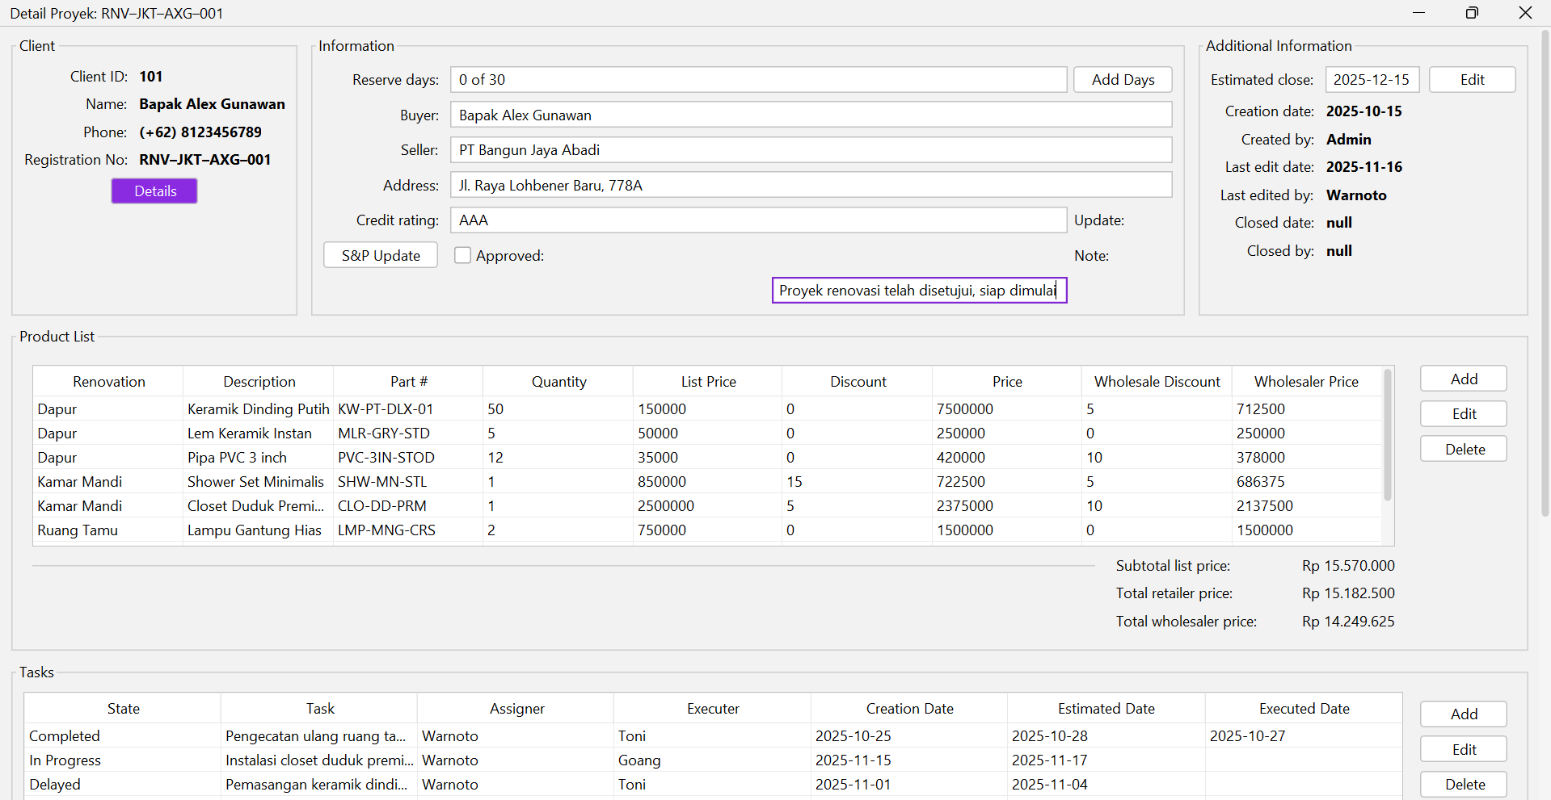
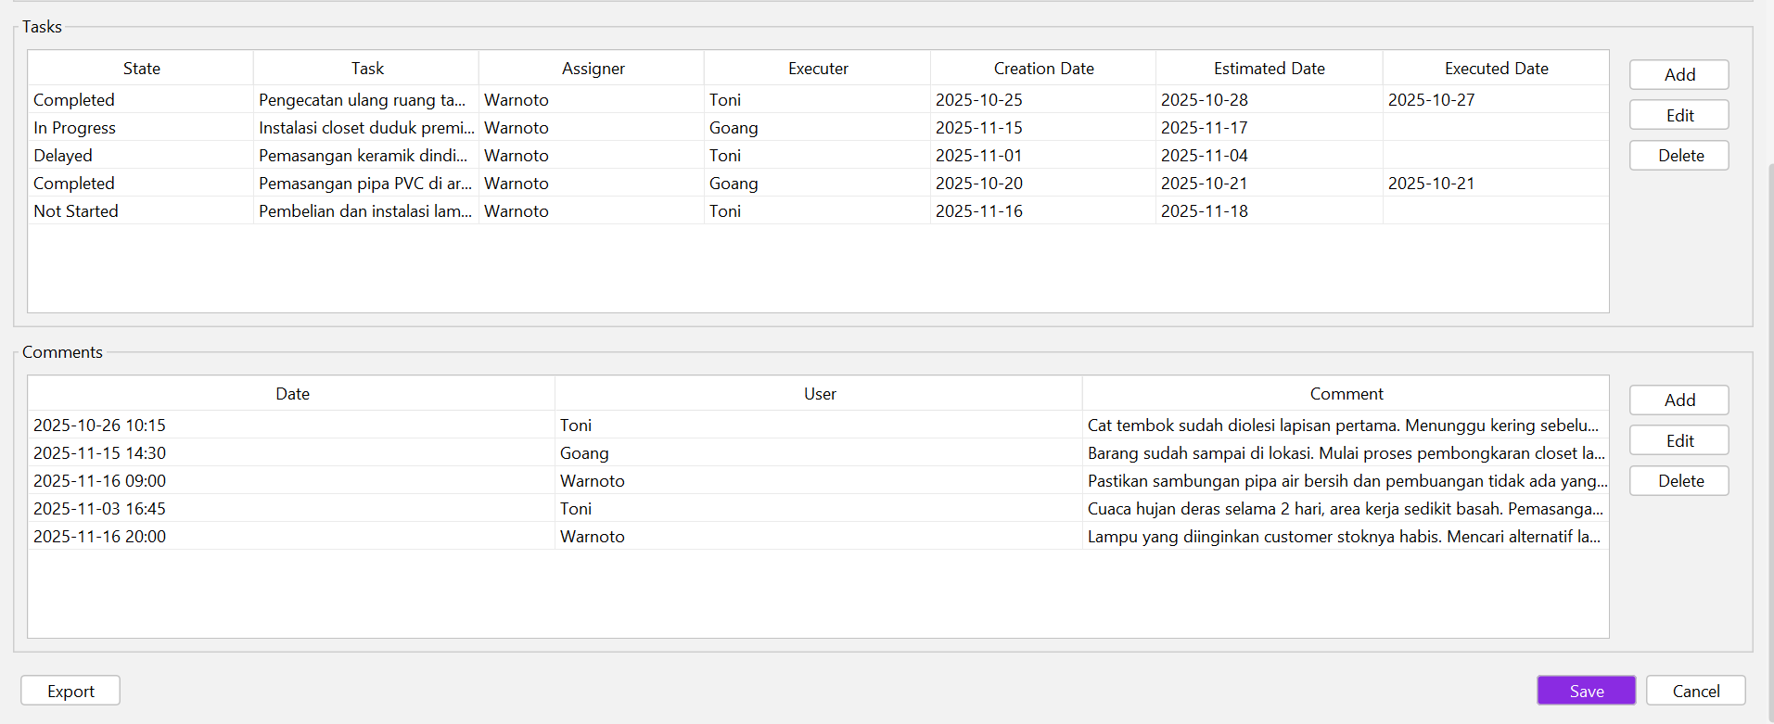

Modul 10_03 Praktikum

Kode Program
import java.awt.Color;
import java.awt.Dimension;
import java.awt.Font;
import java.awt.Insets;
import java.awt.event.ComponentAdapter;
import java.awt.event.ComponentEvent;

import javax.swing.BorderFactory;
import javax.swing.JFrame;
import javax.swing.JLabel;
import javax.swing.JPanel;
import javax.swing.SwingConstants;
import javax.swing.SwingUtilities;
import javax.swing.UIManager;
import javax.swing.UnsupportedLookAndFeelException;

import com.formdev.flatlaf.themes.FlatMacLightLaf;

import net.miginfocom.swing.MigLayout;

public class UISwingResponsif extends JFrame {

private JPanel mainPanel;
private JPanel panel1;
private JPanel panel2;
private JPanel panel3;
private JPanel panel4;
private JPanel panel5;

private static final int COMPACT_VIEW_MAX = 576;
private static final int SPLIT_VIEW_MAX = 768;
private static final int INTERMEDIATE_VIEW_MAX = 992;
private static final int DESKTOP_SMALL_MAX = 1200;
private static final int DESKTOP_STANDARD_MAX = 1400;

public UISwingResponsif() {
setDefaultCloseOperation(JFrame.EXIT_ON_CLOSE);
setMinimumSize(new Dimension(400, 600));

panel1 = createColoredPanel("Panel 1 - Header", new Color(70, 130, 180));
panel2 = createColoredPanel("Panel 2 - Sidebar", new Color(60, 179, 113));
panel3 = createColoredPanel("Panel 3 - Content", new Color(255, 206, 86));
panel4 = createColoredPanel("Panel 4 - Secondary", new Color(147, 112, 219));
panel5 = createColoredPanel("Panel 5 - Footer", new Color(220, 20, 60));

mainPanel = new JPanel();
add(mainPanel);

addComponentListener(new ComponentAdapter() {
@Override
public void componentResized(ComponentEvent e) {
updateLayoutAndTitle();
}

@Override
public void componentMoved(ComponentEvent e) {
updateLayoutAndTitle();
}
});

updateLayoutAndTitle();

pack();
setExtendedState(JFrame.MAXIMIZED_BOTH);
setLocationRelativeTo(null);
}

private void updateLayoutAndTitle() {
Dimension size = getSize();
Insets insets = getInsets();
int innerWidth = size.width - insets.left - insets.right;
int innerHeight = size.height - insets.top - insets.bottom;

String category = getDeviceCategory(innerWidth);
setTitle(category + " | " + innerWidth + " x " + innerHeight + " px");

rebuildLayout(innerWidth);
}

private String getDeviceCategory(int width){
if (width <= COMPACT_VIEW_MAX) return "Compact View (≤576px)";
else if (width <= SPLIT_VIEW_MAX) return "Split View (576-768px)";
else if (width <= INTERMEDIATE_VIEW_MAX) return "Intermediate View (768-992px)";
else if (width <= DESKTOP_SMALL_MAX) return "Desktop Small (992-1200px)";
else if (width <= DESKTOP_STANDARD_MAX) return "Desktop Standard (1200-1400px)";
else return "Desktop Large (>1400px)";
}

private void rebuildLayout(int width) {
mainPanel.removeAll();
mainPanel.setLayout(new MigLayout("fill, insets 0, gap 0"));

if (width <= COMPACT_VIEW_MAX) {
mainPanel.add(panel1, "grow, wrap");
mainPanel.add(panel2, "grow, wrap");
mainPanel.add(panel3, "grow, push, h 300::, wrap");
mainPanel.add(panel4, "grow, wrap");
mainPanel.add(panel5, "grow, wrap");
}

else if (width <= SPLIT_VIEW_MAX) {
mainPanel.add(panel1, "span 2, growx, wrap");
mainPanel.add(panel2, "w 200!, growy");
mainPanel.add(panel3, "grow, push, wrap");
mainPanel.add(panel4, "span 2, growx, wrap");
mainPanel.add(panel5, "span 2, growx, wrap");
}

else if (width <= INTERMEDIATE_VIEW_MAX) {
mainPanel.add(panel1, "span 2, growx, wrap");
mainPanel.add(panel2, "w 300!, growy");
mainPanel.add(panel3, "grow, push, spany 2");
mainPanel.add(panel4, "growx, h 180!, wrap");
mainPanel.add(panel5, "span 2, growx, wrap");
}

else if (width <= DESKTOP_SMALL_MAX) {
mainPanel.add(panel1, "span 3, growx, wrap");
mainPanel.add(panel2, "growy, span 1 2, w 300!, h 100%"); // span 1 kolom x 2 baris
mainPanel.add(panel3, "grow, push, wrap");
mainPanel.add(panel4, "h 25%, growx, wrap");
mainPanel.add(panel5, "span 3, growx");
}

else if (width <= DESKTOP_STANDARD_MAX) {
mainPanel.add(panel1, "span 3, growx, wrap");
mainPanel.add(panel2, "w 300!, growy");
mainPanel.add(panel3, "grow, pushx 2, pushy");
mainPanel.add(panel4, "grow, wrap");
mainPanel.add(panel5, "span 3, growx, wrap");
}

else {
mainPanel.add(panel1, "span 3, growx, wrap");
mainPanel.add(panel2, "w 340!, growy");
mainPanel.add(panel3, "grow, pushx 2, pushy");
mainPanel.add(panel4, "grow, wrap");
mainPanel.add(panel5, "span 3, growx, wrap");
}

mainPanel.revalidate();
mainPanel.repaint();

}

private JPanel createColoredPanel(String title, Color background) {
JPanel panel = new JPanel(new MigLayout("fill, insets 0"));
panel.setBackground(background);
panel.setBorder(BorderFactory.createEmptyBorder(12, 12, 12, 12));
JLabel label = new JLabel(title, SwingConstants.CENTER);
label.setFont(new Font("Inter", Font.BOLD, 16));
label.setForeground(Color.WHITE);
label.setOpaque(false);
panel.add(label, "grow, align center");

return panel;
}

public static void main(String[] args) {
try {
UIManager.setLookAndFeel(new FlatMacLightLaf());
} catch (UnsupportedLookAndFeelException e) {
e.printStackTrace();
}
SwingUtilities.invokeLater(() -> {
new UISwingResponsif().setVisible(true);
});
}
}

Hasil Run
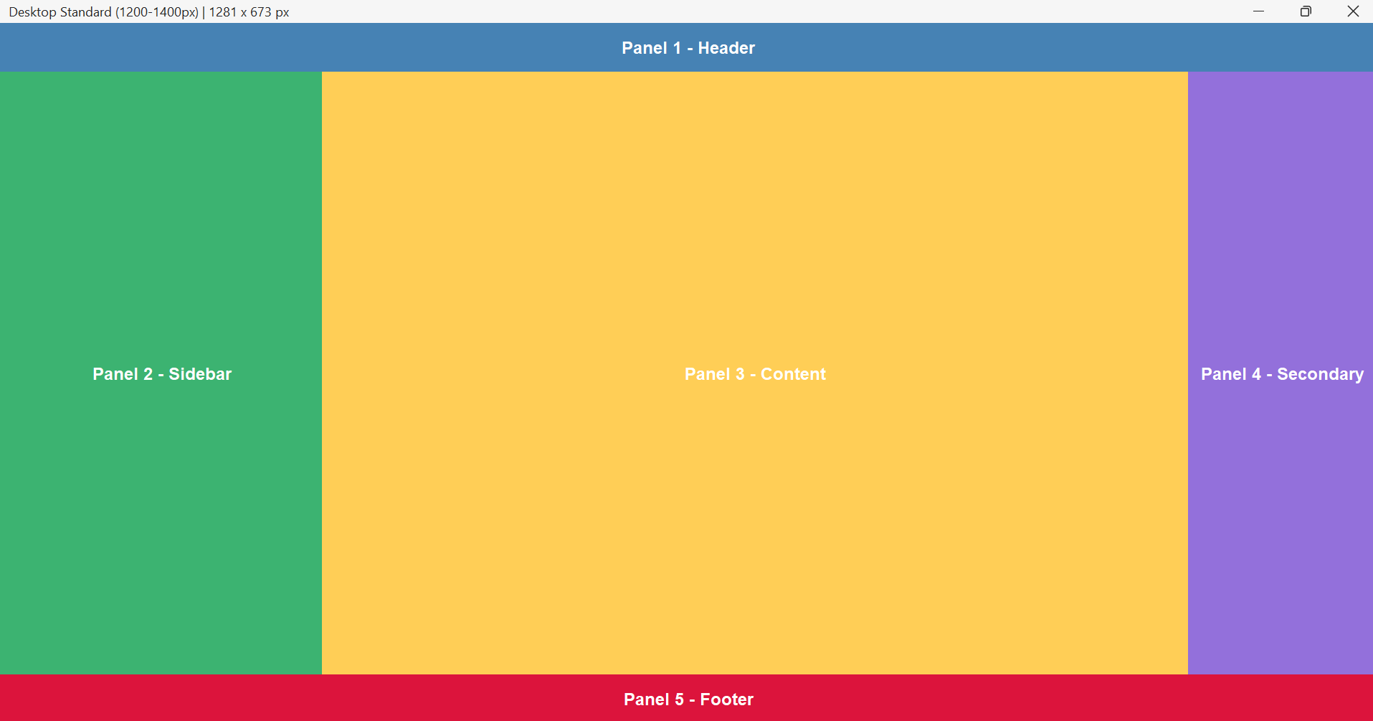
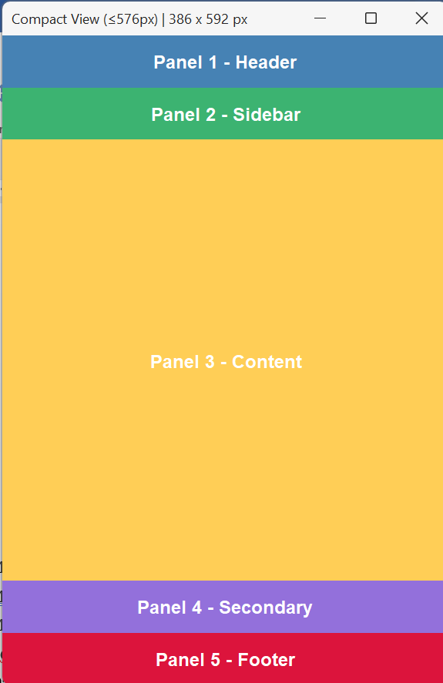

Modul 10_03 Latihan

Kode Program
import java.awt.*;
import java.awt.event.*;
import javax.swing.*;
import javax.swing.border.TitledBorder;
import javax.swing.table.DefaultTableModel;
import net.miginfocom.swing.MigLayout;
import com.formdev.flatlaf.FlatLaf;
import com.formdev.flatlaf.FlatLightLaf;

import java.util.Collections;

public class RenovationAppTugas {

private static String buttonColor = "background: $Component.accentColor; foreground: #FFFFFF;";

private static final int COMPACT_VIEW_MAX = 576;
private static final int SPLIT_VIEW_MAX = 768;
private static final int INTERMEDIATE_VIEW_MAX = 992;
private static final int DESKTOP_SMALL_MAX = 1200;
private static final int DESKTOP_STANDARD_MAX = 1400;

public static void main(String[] args) {

try {
FlatLaf.setGlobalExtraDefaults(Collections.singletonMap("@accentColor", "#8A2BE2"));
UIManager.setLookAndFeel(new FlatLightLaf());
} catch (Exception e) {
try {
UIManager.setLookAndFeel(UIManager.getSystemLookAndFeelClassName());
} catch (Exception ex) {
}
}

SwingUtilities.invokeLater(() -> {

/** Deklarasi Frame **/
JFrame frame = new JFrame("Detail Proyek: RNV–JKT–AXG–001");
frame.setDefaultCloseOperation(JFrame.EXIT_ON_CLOSE);
frame.setPreferredSize(new Dimension(1024, 768));
frame.setMinimumSize(new Dimension(800, 600));

/** Deklarasi Panel Utama **/
JPanel panelUtama = new JPanel(new MigLayout(
"fill, wrap 3",
"[][grow][]",
"[][grow][grow][grow][]"
));

/** Deklarasi Panel Information **/
JPanel panelInformation = new JPanel(new MigLayout(
"wrap 3",
"[right]10[left, grow, fill]5[fill]"
));
panelInformation.setBorder(new TitledBorder("Information"));

panelInformation.add(new JLabel("Reserve days:"));
panelInformation.add(new JTextField("0 of 30"));
panelInformation.add(new JButton("Add Days"));

panelInformation.add(new JLabel("Buyer:"));
panelInformation.add(new JTextField("Bapak Alex Gunawan"), "span 2");

panelInformation.add(new JLabel("Seller:"));
panelInformation.add(new JTextField("PT Bangun Jaya Abadi"), "span 2");

panelInformation.add(new JLabel("Address:"));
panelInformation.add(new JTextField("Jl. Raya Lohbener Baru, 778A"), "span 2");

panelInformation.add(new JLabel("Credit rating:"));
panelInformation.add(new JTextField("AAA"));

panelInformation.add(new JLabel("Update:"));
panelInformation.add(new JButton("S&P Update"));

panelInformation.add(new JCheckBox("Approved:"));

panelInformation.add(new JLabel("Note:"));
panelInformation.add(new JTextField("Proyek renovasi telah disetujui, siap dimulai"), "span 2");

/** Deklarasi Panel Client **/
JPanel panelClient = new JPanel(new MigLayout(
"wrap 2",
"[right]10[left]"
));
panelClient.setBorder(new TitledBorder("Client"));

panelClient.add(new JLabel("Client ID:"));
panelClient.add(new JLabel("<html><b>101</b></html>"));

panelClient.add(new JLabel("Name:"));
panelClient.add(new JLabel("<html><b>Bapak Alex Gunawan</b></html>"));

panelClient.add(new JLabel("Phone:"));
panelClient.add(new JLabel("<html><b>(+62) 8123456789</b></html>"));

panelClient.add(new JLabel("Registration No:"));
panelClient.add(new JLabel("<html><b>RNV–JKT–AXG–001</b></html>"));

JButton buttonDetails = new JButton("Details");
buttonDetails.putClientProperty("FlatLaf.style", buttonColor);
panelClient.add(buttonDetails, "span 2, center");

panelUtama.add(panelClient, "grow");

panelUtama.add(panelInformation, "grow");

/** Deklarasi Panel Additional Information **/
JPanel panelAdditional = new JPanel(new MigLayout("wrap 3", "[right]10[left,grow,fill][]"));
panelAdditional.setBorder(new TitledBorder("Additional Information"));

panelAdditional.add(new JLabel("Estimated close:"));
panelAdditional.add(new JTextField("2025-12-15"), "wmin pref");
panelAdditional.add(new JButton("Edit"), "wmax pref");

panelAdditional.add(new JLabel("Creation date:"));
panelAdditional.add(new JLabel("<html><b>2025-10-15</b></html>"), "span 2");

panelAdditional.add(new JLabel("Created by:"));
panelAdditional.add(new JLabel("<html><b>Admin</b></html>"), "span 2");

panelAdditional.add(new JLabel("Last edit date:"));
panelAdditional.add(new JLabel("<html><b>2025-11-16</b></html>"), "span 2");

panelAdditional.add(new JLabel("Last edited by:"));
panelAdditional.add(new JLabel("<html><b>Warnoto</b></html>"), "span 2");

panelAdditional.add(new JLabel("Closed date:"));
panelAdditional.add(new JLabel("<html><b>null</b></html>"), "span 2");

panelAdditional.add(new JLabel("Closed by:"));
panelAdditional.add(new JLabel("<html><b>null</b></html>"), "span 2");

panelUtama.add(panelAdditional, "grow");

/** Deklarasi Panel Product List **/
JPanel panelProduk = new JPanel(new MigLayout("", "[grow][]"));
panelProduk.setBorder(new TitledBorder("Product List"));

/** Deklarasi Panel (Table) Product List **/
JPanel panelTableProductList = new JPanel(new MigLayout("wrap 3", "[grow][left][right]", "[][ ][][ ]"));

String[] kolomTableProductList = {
"Renovation", "Description", "Part #", "Quantity", "List Price",
"Discount", "Price", "Wholesale Discount", "Wholesaler Price"
};

Object[][] dataProductList = {
{ "Dapur", "Keramik Dinding Putih", "KW-PT-DLX-01", 50, 150000, 0, 7500000L, 5, 712500L },
{ "Dapur", "Lem Keramik Instan", "MLR-GRY-STD", 5, 50000, 0, 250000L, 0, 250000L },
{ "Dapur", "Pipa PVC 3 inch", "PVC-3IN-STOD", 12, 35000, 0, 420000L, 10, 378000L },
{ "Kamar Mandi", "Shower Set Minimalis", "SHW-MN-STL", 1, 850000, 15, 722500L, 5, 686375L },
{ "Kamar Mandi", "Closet Duduk Premium", "CLO-DD-PRM", 1, 2500000, 5, 2375000L, 10, 2137500L },
{ "Ruang Tamu", "Lampu Gantung Hias", "LMP-MNG-CRS", 2, 750000, 0, 1500000L, 0, 1500000L },
{ "Ruang Tamu", "Cat Tembok Putih 20L", "CAT-PT-20L", 3, 450000, 10, 1215000L, 15, 1032750L },
{ "Garasi", "Semen PC 50Kg", "SMN-PC-50", 20, 60000, 0, 1200000L, 5, 1140000L },
};

DefaultTableModel tableModelProductList = new DefaultTableModel(dataProductList, kolomTableProductList);
JTable tableProductList = new JTable(tableModelProductList);
tableProductList.setAutoCreateRowSorter(true);
tableProductList.setShowGrid(true);

JScrollPane scrollPaneTableProductList = new JScrollPane(tableProductList);
panelTableProductList.add(scrollPaneTableProductList, "span 3, growx, h 150");

panelTableProductList.add(new JSeparator(), "growx");
panelTableProductList.add(new JLabel("Subtotal list price:"), "gapx 10");
panelTableProductList.add(new JLabel("Rp 15.570.000"), "gapx 30");

panelTableProductList.add(new JLabel("Total retailer price:"), "skip 1, gapx 10");
panelTableProductList.add(new JLabel("Rp 15.182.500"), "gapx 30");

panelTableProductList.add(new JLabel("Total wholesaler price:"), "skip 1, gapx 10");
panelTableProductList.add(new JLabel("Rp 14.249.625"), "gapx 30");

panelProduk.add(panelTableProductList, "grow");

/** Deklarasi Panel (Button) Product List **/
JPanel panelButtonProductList = new JPanel(new MigLayout("wrap 1"));

panelButtonProductList.add(new JButton("Add"));
panelButtonProductList.add(new JButton("Edit"));
panelButtonProductList.add(new JButton("Delete"));

panelProduk.add(panelButtonProductList, "grow");
panelUtama.add(panelProduk, "growx, span 3");

/** Deklarasi Panel Tasks **/
JPanel panelTask = new JPanel(new MigLayout("", "[grow][]"));
panelTask.setBorder(new TitledBorder("Tasks"));

String[] kolomTableTask = {
"State", "Task", "Assigner", "Executer",
"Creation Date", "Estimated Date", "Executed Date"
};

Object[][] dataTask = {
{ "Completed", "Pengecatan ulang ruang tamu", "Warnoto", "Toni", "2025-10-25", "2025-10-28", "2025-10-27" },
{ "In Progress", "Instalasi closet duduk premium", "Warnoto", "Goang", "2025-11-15", "2025-11-17", null },
{ "Delayed", "Pemasangan keramik dinding dapur", "Warnoto", "Toni", "2025-11-01", "2025-11-04", null },
{ "Completed", "Pemasangan pipa PVC di area garasi", "Warnoto", "Goang", "2025-10-20", "2025-10-21", "2025-10-21" },
{ "Not Started", "Pembelian dan instalasi lampu gantung hias", "Warnoto", "Toni", "2025-11-16", "2025-11-18", null }
};

DefaultTableModel tableModelTask = new DefaultTableModel(dataTask, kolomTableTask);
JTable tableTask = new JTable(tableModelTask);
tableTask.setAutoCreateRowSorter(true);
tableTask.setShowGrid(true);

JScrollPane scrollPaneTableTask = new JScrollPane(tableTask);
panelTask.add(scrollPaneTableTask, "grow, hmin 150, hmax 190");

/** Deklarasi Panel Controls */
JPanel panelControls = new JPanel(new MigLayout("insets 0", "[grow,left][right]"));

/** Deklarasi Panel Controls (Left) */
JPanel panelControlsLeft = new JPanel(new MigLayout());
panelControlsLeft.add(new JButton("Export"));
panelControls.add(panelControlsLeft);

/** Deklarasi Panel (Button) Tasks */
JPanel panelButtonTask = new JPanel(new MigLayout("wrap 1"));
panelButtonTask.add(new JButton("Add"));
panelButtonTask.add(new JButton("Edit"));
panelButtonTask.add(new JButton("Delete"));
panelTask.add(panelButtonTask, "grow");
panelUtama.add(panelTask, "grow, span 3");

/** Deklarasi Panel Comments */
JPanel panelComments = new JPanel(new MigLayout("", "[grow][]"));
panelComments.setBorder(new TitledBorder("Comments"));

String[] kolomTableComment = { "Date", "User", "Comment" };

Object[][] dataComment = {
{ "2025-10-26 10:15", "Toni", "Cat tembok sudah diolesi lapisan pertama. Menunggu kering sebelum lapisan kedua." },
{ "2025-11-15 14:30", "Goang", "Barang sudah sampai di lokasi. Mulai proses pembongkaran closet lama sore ini." },
{ "2025-11-16 09:00", "Warnoto", "Pastikan sambungan pipa air bersih dan pembuangan tidak ada yang bocor, cek tekanannya." },
{ "2025-11-03 16:45", "Toni", "Cuaca hujan deras selama 2 hari, area kerja sedikit basah. Pemasangan ditunda besok pagi." },
{ "2025-11-16 20:00", "Warnoto", "Lampu yang diinginkan customer stoknya habis. Mencari alternatif lampu model serupa." },
};

DefaultTableModel tableModelComment = new DefaultTableModel(dataComment, kolomTableComment);
JTable tableComment = new JTable(tableModelComment);
tableComment.setAutoCreateRowSorter(true);
tableComment.setShowGrid(true);

JScrollPane scrollPaneTableComment = new JScrollPane(tableComment);
panelComments.add(scrollPaneTableComment, "grow, hmin 150, hmax 190");

/** Deklarasi Panel (Button) Comments */
JPanel panelButtonComment = new JPanel(new MigLayout("wrap 1"));
panelButtonComment.add(new JButton("Add"));
panelButtonComment.add(new JButton("Edit"));
panelButtonComment.add(new JButton("Delete"));
panelComments.add(panelButtonComment, "grow");
panelUtama.add(panelComments, "grow, span 3");

/** Deklarasi ScrollPane **/
JScrollPane scrollPane = new JScrollPane(panelUtama);
scrollPane.getVerticalScrollBar().setUnitIncrement(18);
scrollPane.getVerticalScrollBar().putClientProperty("JScrollBar.fastWheelScrolling", true);
scrollPane.putClientProperty("JScrollPane.fastWheelScrolling", true);
scrollPane.setVerticalScrollBarPolicy(JScrollPane.VERTICAL_SCROLLBAR_AS_NEEDED);

frame.add(scrollPane);
frame.pack();
frame.setLocationRelativeTo(null);
frame.setVisible(true);

installModernScrollChaining(frame, scrollPane);

/** Deklarasi Panel Controls (Right) */
JPanel panelControlsRight = new JPanel(new MigLayout());
JButton buttonSave = new JButton("Save");
buttonSave.putClientProperty("FlatLaf.style", buttonColor);
panelControlsRight.add(buttonSave);
panelControlsRight.add(new JButton("Cancel"));
panelControls.add(panelControlsRight);
panelUtama.add(panelControls, "grow, span 3");
});
}

private static void installModernScrollChaining(JFrame frame, JScrollPane mainScrollPane) {
final double[] accumulatedDelta = {0.0};

Toolkit.getDefaultToolkit().addAWTEventListener(event -> {
if (!(event instanceof MouseWheelEvent)) return;
MouseWheelEvent mwe = (MouseWheelEvent) event;
if (mwe.isConsumed()) return;

Component source = mwe.getComponent();
if (!SwingUtilities.isDescendingFrom(source, frame)) return;

JScrollPane inner = null;
for (Component c = source; c != null; c = c.getParent()) {
if (c instanceof JScrollPane) {
JScrollPane sp = (JScrollPane) c;
if (sp != mainScrollPane) {
inner = sp;
break;
}
}
}

if (inner == null) {
return;
}

JScrollBar vbar = inner.getVerticalScrollBar();
double rotation = mwe.getPreciseWheelRotation();
if (rotation == 0) return;

boolean scrollDown = rotation > 0;
boolean scrollUp = rotation < 0;
boolean canScrollFurther = false;

if (vbar != null && vbar.isVisible()) {
int value = vbar.getValue();
int extent = vbar.getModel().getExtent();
int max = vbar.getMaximum();

boolean atBottom = (value + extent >= max - 1);
boolean atTop = (value <= 1);

canScrollFurther = (scrollDown && !atBottom) || (scrollUp && !atTop);
} else {
canScrollFurther = false;
}
if (canScrollFurther) {
accumulatedDelta[0] = 0.0;
return;
}
accumulatedDelta[0] += rotation;
if (Math.abs(accumulatedDelta[0]) < 0.7) return;

JScrollBar mainBar = mainScrollPane.getVerticalScrollBar();
int delta = (int) Math.signum(accumulatedDelta[0]) * mainBar.getUnitIncrement();

int newValue = mainBar.getValue() + delta;
newValue = Math.max(mainBar.getMinimum(),
Math.min(mainBar.getMaximum() - mainBar.getModel().getExtent(), newValue));

mainBar.setValue(newValue);

accumulatedDelta[0] = 0.0;
mwe.consume();
}, AWTEvent.MOUSE_WHEEL_EVENT_MASK);
}
}

Hasil Run
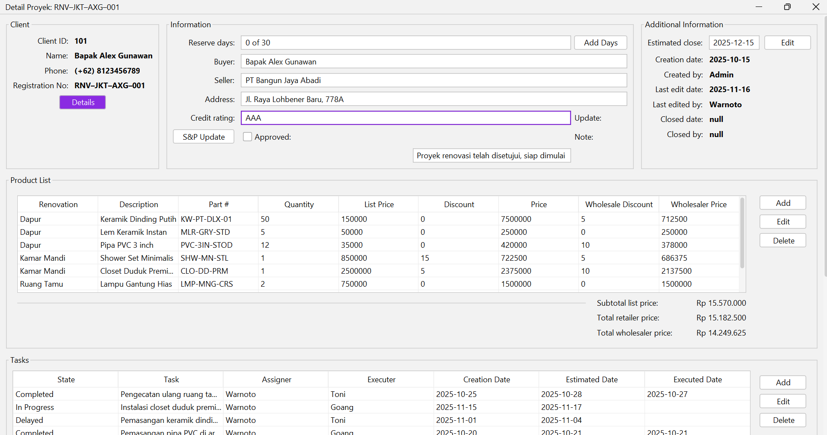
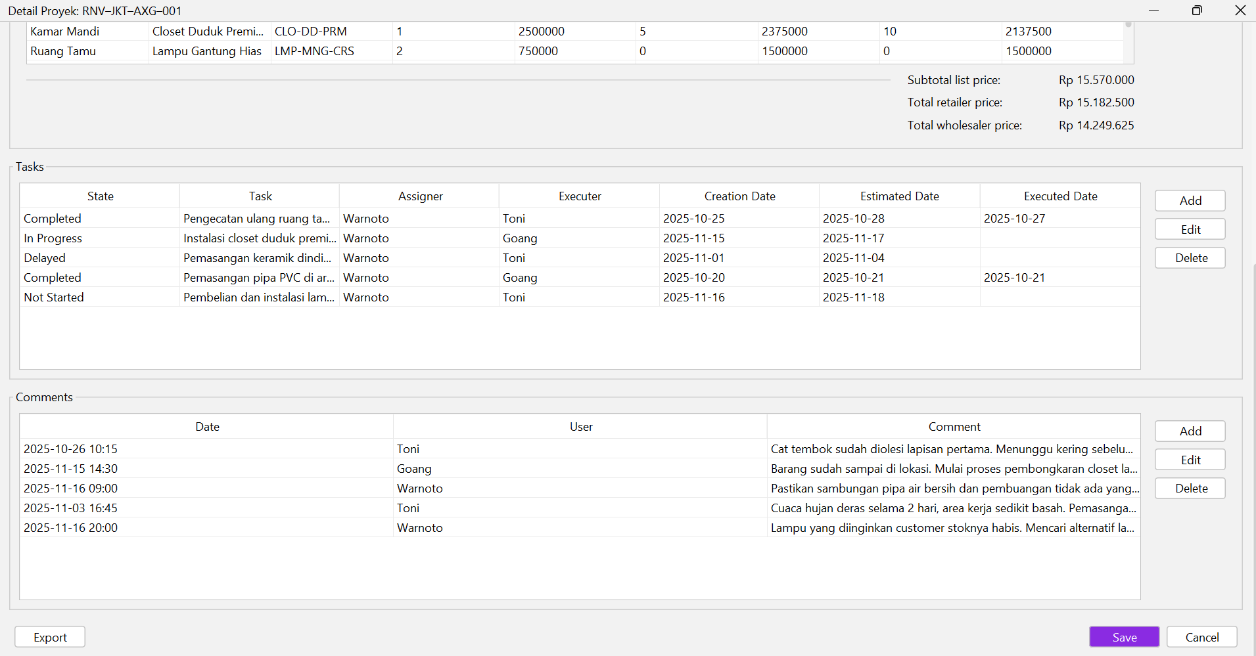

Modul 11 Praktikum

Panel Dashboard
package view.konten;

import java.awt.Color;
import java.awt.Font;

import javax.swing.JLabel;
import javax.swing.JPanel;

import net.miginfocom.swing.MigLayout;

public class PanelDashboard extends JPanel{

public PanelDashboard() {
initializeUI();
}

private void initializeUI() {
setLayout(new MigLayout("fill, insets 60", "[grow]", "[grow]" ));
setBackground(Color.WHITE);
setOpaque(true);

JLabel title = new JLabel("Panel Dasboard Tisa");
title.setFont(new Font("Inter", Font.BOLD, 36));
title.setForeground(new Color(0, 48, 73));

JLabel info = new JLabel("Deskripsi Panel Dashboard Tisa");
info.setFont(new Font("Inter", Font.PLAIN, 16));
info.setForeground(new Color(98, 117, 138));

add(title, "alignx center, wrap 30");
add(info, "alignx center");

}
}

Hasil Run
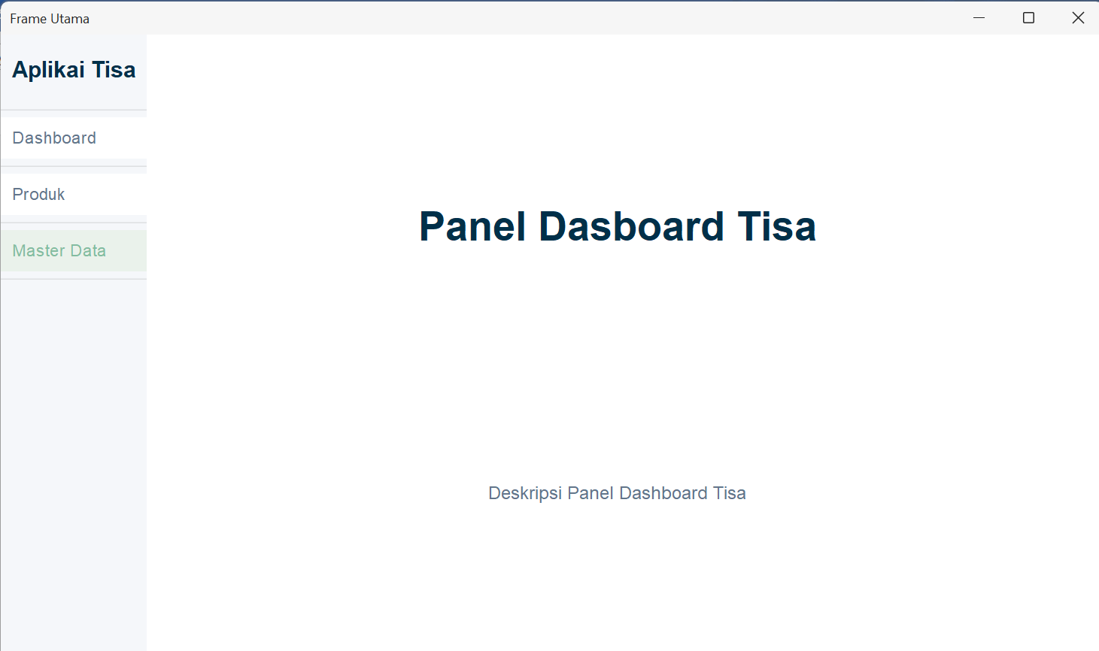

Panel Kategori
package view.konten;

import java.awt.Color;
import java.awt.Font;

import javax.swing.JLabel;
import javax.swing.JPanel;

import net.miginfocom.swing.MigLayout;

public class PanelKategori extends JPanel {

public PanelKategori() {
initializeUI();
}

private void initializeUI() {
setLayout(new MigLayout("fill, insets 60", "[grow]", "[grow]"));
setBackground(Color.WHITE);
setOpaque(true);

JLabel title = new JLabel("Panel Kategori Tisa");
title.setFont(new Font("Inter", Font.BOLD, 36));
title.setForeground(new Color(0, 48, 73));

JLabel info = new JLabel("Deskripsi Panel Kategori");
info.setFont(new Font("Inter", Font.PLAIN, 16));
info.setForeground(new Color(98, 117, 138));

add(title, "alignx center, wrap 30");
add(info, "alignx center");
}
}

Hasil Run
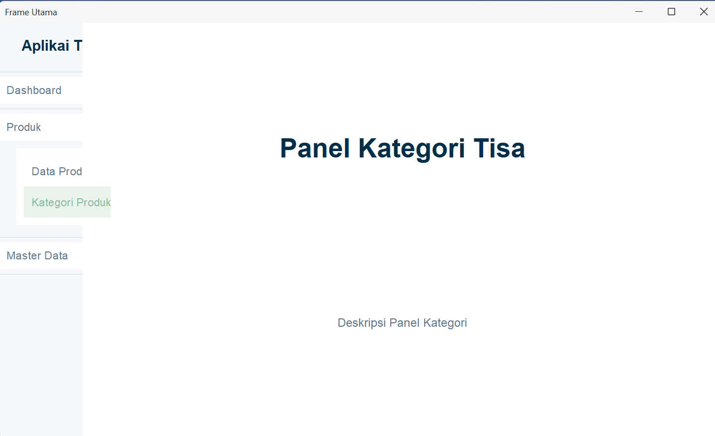

Panel Produk
package view.konten;

import java.awt.Color;
import java.awt.Font;

import javax.swing.JLabel;
import javax.swing.JPanel;

import net.miginfocom.swing.MigLayout;

public class PanelProduk extends JPanel {

public PanelProduk() {
initializeUI();
}

private void initializeUI() {
setLayout(new MigLayout("fill, insets 60", "[grow]", "[grow]"));
setBackground(Color.WHITE);
setOpaque(true);

JLabel title = new JLabel("Panel Produk Tisa");
title.setFont(new Font("Inter", Font.BOLD, 36));
title.setForeground(new Color(0, 48, 73));

JLabel info = new JLabel("Deskripsi Panel Produk");
info.setFont(new Font("Inter", Font.PLAIN, 16));
info.setForeground(new Color(98, 117, 138));

add(title, "alignx center, wrap 30");
add(info, "alignx center");
}
}

Hasil Run
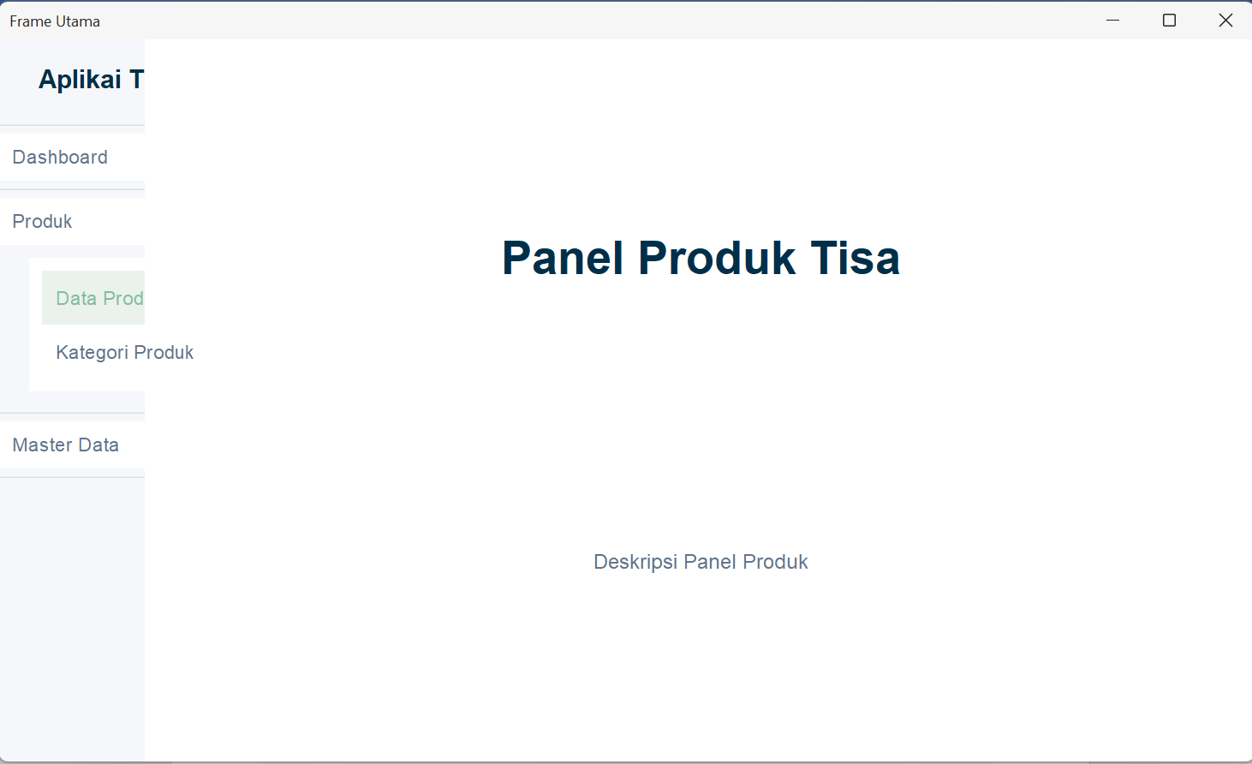

Panel Satuan
package view.konten;

import java.awt.Color;
import java.awt.Font;

import javax.swing.JLabel;
import javax.swing.JPanel;

import net.miginfocom.swing.MigLayout;

public class PanelSatuan extends JPanel {

public PanelSatuan() {
initializeUI();
}

private void initializeUI() {
setLayout(new MigLayout("fill, insets 60", "[grow]", "[grow]"));
setBackground(Color.WHITE);
setOpaque(true);

JLabel title = new JLabel("Panel Satuan Tisa");
title.setFont(new Font("Inter", Font.BOLD, 36));
title.setForeground(new Color(0, 48, 73));

JLabel info = new JLabel("Deskripsi Panel Satuan");
info.setFont(new Font("Inter", Font.PLAIN, 16));
info.setForeground(new Color(98, 117, 138));

add(title, "alignx center, wrap 30");
add(info, "alignx center");
}
}

Hasil Run
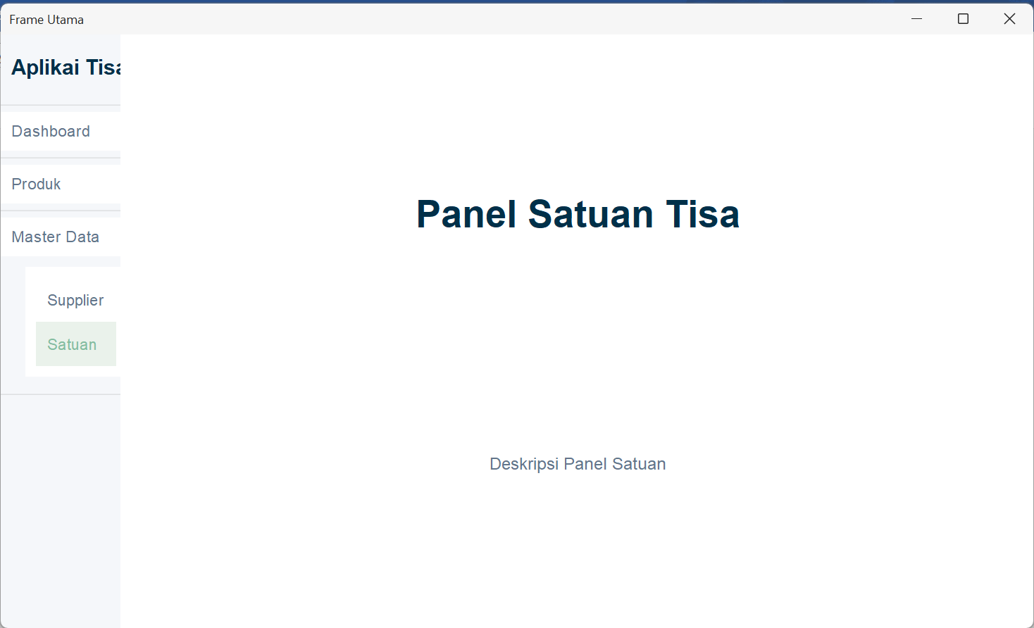

Panel Supplier
package view.konten;

import java.awt.Color;
import java.awt.Font;

import javax.swing.JLabel;
import javax.swing.JPanel;

import net.miginfocom.swing.MigLayout;

public class PanelSupplier extends JPanel {

public PanelSupplier() {
initializeUI();
}

private void initializeUI() {
setLayout(new MigLayout("fill, insets 60", "[grow]", "[grow]"));
setBackground(Color.WHITE);
setOpaque(true);

JLabel title = new JLabel("Panel Supplier Tisa");
title.setFont(new Font("Inter", Font.BOLD, 36));
title.setForeground(new Color(0, 48, 73));

JLabel info = new JLabel("Deskripsi Panel Supplier");
info.setFont(new Font("Inter", Font.PLAIN, 16));
info.setForeground(new Color(98, 117, 138));

add(title, "alignx center, wrap 30");
add(info, "alignx center");
}
}

Hasil Run
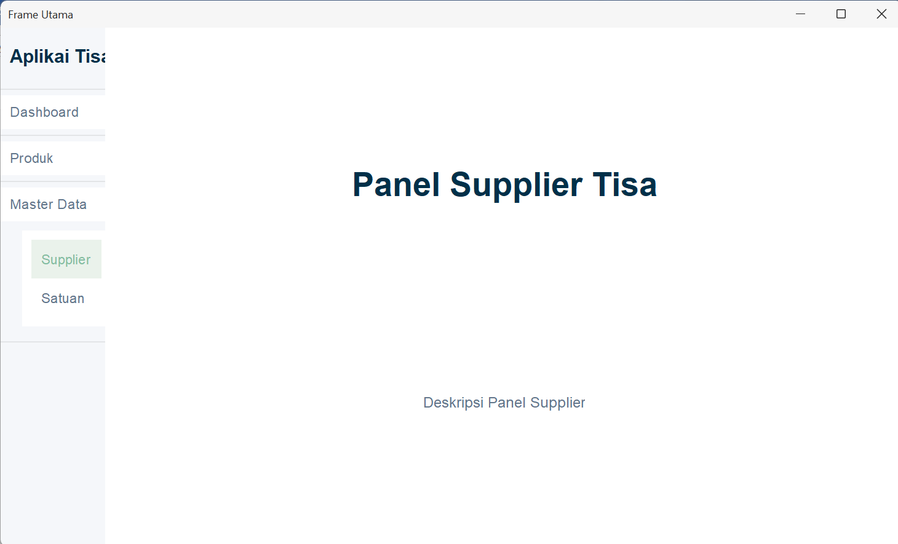

Frame Utama
package view;

import java.awt.CardLayout;
import java.awt.Color;
import java.awt.Dimension;
import java.util.ArrayList;
import java.util.List;

import javax.swing.JFrame;
import javax.swing.JPanel;

import model.MenuItem;
import net.miginfocom.swing.MigLayout;
import view.konten.PanelDashboard;
import view.konten.PanelKategori;
import view.konten.PanelProduk;
import view.konten.PanelSatuan;
import view.konten.PanelSupplier;
import view.menu.PanelMenu;

public class FrameUtama extends JFrame {

MenuItem menuDashboard;
MenuItem menuProduk;
MenuItem menuMasterData;
List<MenuItem> listDaftarMenuItem;

CardLayout cardLayout;
JPanel panelKonten;
PanelMenu panelMenu;

public FrameUtama() {
initializeUI();
setupPanelKonten();
setupPanelMenu();
addPanel();

}

private void initializeUI() {
setTitle("Frame Utama");
setDefaultCloseOperation(JFrame.EXIT_ON_CLOSE);
setPreferredSize(new Dimension(1280, 720));
setMinimumSize(new Dimension(992, 600));
setLocationRelativeTo(null);
setLayout(new MigLayout(
"fill, insets 0, gap 0",
"[114!][grow]",
"[grow]"
));

//throw new UnsupportedOperationException("Unimplemented method 'initializeUI'");
}

private void setupPanelMenu() {
listDaftarMenuItem = new ArrayList<>();

menuDashboard = new MenuItem("Dashboard", "dashboard");
menuProduk = new MenuItem("Produk");
menuMasterData = new MenuItem("Master Data");

menuProduk.addSubMenuItem(new MenuItem("Data Produk", "produk"));
menuProduk.addSubMenuItem(new MenuItem("Kategori Produk", "kategori"));
menuMasterData.addSubMenuItem(new MenuItem("Supplier", "supplier"));
menuMasterData.addSubMenuItem(new MenuItem("Satuan", "satuan"));

listDaftarMenuItem.add(menuDashboard);
listDaftarMenuItem.add(menuProduk);
listDaftarMenuItem.add(menuMasterData);

panelMenu = new PanelMenu(listDaftarMenuItem, cardLayout, panelKonten);
panelMenu.setBackground(new Color(245, 247, 250));

//throw new UnsupportedOperationException("Unimplemented method 'setupPanelMenu'");
}

private void setupPanelKonten() {
cardLayout = new CardLayout();
panelKonten = new JPanel(cardLayout);

panelKonten.add(new PanelDashboard(), "dashboard");
panelKonten.add(new PanelProduk(), "produk");
panelKonten.add(new PanelKategori(), "kategori");
panelKonten.add(new PanelSupplier(), "supplier");
panelKonten.add(new PanelSatuan(), "satuan");

//throw new UnsupportedOperationException("Unimplemented method 'setupPanelKonten'");
}
private void addPanel() {
add(panelMenu, "growy");
add(panelKonten, "grow");

//throw new UnsupportedOperationException("Unimplemented method 'addPanel'");
}

}

Dashboard App
import javax.swing.SwingUtilities;
import javax.swing.UIManager;

import com.formdev.flatlaf.themes.FlatMacLightLaf;

import view.FrameUtama;

public class DashboardTisaApp {
public static void main(String[] args) //throws Exception
{try {
UIManager.setLookAndFeel(new FlatMacLightLaf());
} catch (Exception e) {
System.err.println(e.getMessage());
}

SwingUtilities.invokeLater(() -> {
new FrameUtama().setVisible(true);
});

//System.out.println("Hello, World!");
}
}

Modul 10_03 Tugas

Kode program
- PanelRenovation
package view.konten;

import java.awt.Color;
import java.awt.Font;

import javax.swing.JLabel;
import javax.swing.JPanel;

import net.miginfocom.swing.MigLayout;

public class PanelRenovation extends JPanel {

public PanelRenovation() {
initializeUI();
}

private void initializeUI() {
setLayout(new MigLayout("fill, insets 60", "[grow]", "[grow]"));
setBackground(Color.WHITE);
setOpaque(true);

JLabel title = new JLabel("Renovation App");
title.setFont(new Font("Inter", Font.BOLD, 36));
title.setForeground(new Color(0, 48, 73));

JLabel info = new JLabel("Deskripsi Panel Renovation App");
info.setFont(new Font("Inter", Font.PLAIN, 16));
info.setForeground(new Color(98, 117, 138));

add(title, "alignx center, wrap 30");
add(info, "alignx center");
}
}

- PanelRenovasi
package view.konten;

import java.awt.*;
import java.awt.event.*;
import javax.swing.*;
import javax.swing.border.TitledBorder;
import javax.swing.event.AncestorEvent;
import javax.swing.event.AncestorListener;
import javax.swing.table.DefaultTableModel;

//import com.formdev.flatlaf.FlatLaf;

import net.miginfocom.swing.MigLayout;

public class PanelRenovasi extends JPanel {

private static String buttonColor = "background: $Component.accentColor; foreground: #FFFFFF;";

public PanelRenovasi() {

setLayout(new BorderLayout());
setBackground(Color.WHITE);

// Panel utama yang berisi seluruh komponen
JPanel panelUtama = new JPanel(new MigLayout(
"fill, wrap 3",
"[][grow][]",
"[][grow][grow][grow][]"
));

JPanel panelClient = new JPanel(new MigLayout("wrap 2", "[right]10[left]"));
panelClient.setBorder(new TitledBorder("Client"));

panelClient.add(new JLabel("Client ID:"));
panelClient.add(new JLabel("<html><b>101</b></html>"));

panelClient.add(new JLabel("Name:"));
panelClient.add(new JLabel("<html><b>Bapak Alex Gunawan</b></html>"));

panelClient.add(new JLabel("Phone:"));
panelClient.add(new JLabel("<html><b>(+62) 8123456789</b></html>"));

panelClient.add(new JLabel("Registration No:"));
panelClient.add(new JLabel("<html><b>RNV–JKT–AXG–001</b></html>"));

JButton buttonDetails = new JButton("Details");
buttonDetails.putClientProperty("FlatLaf.style", buttonColor);
panelClient.add(buttonDetails, "span 2, center");

panelUtama.add(panelClient, "grow");

JPanel panelInformation = new JPanel(new MigLayout(
"wrap 3",
"[right]10[left,grow,fill][fill]"
));
panelInformation.setBorder(new TitledBorder("Information"));

panelInformation.add(new JLabel("Reserve days:"));
panelInformation.add(new JTextField("0 of 30"));
panelInformation.add(new JButton("Add Days"));

panelInformation.add(new JLabel("Buyer:"));
panelInformation.add(new JTextField("Bapak Alex Gunawan"), "span 2");

panelInformation.add(new JLabel("Seller:"));
panelInformation.add(new JTextField("PT Bangun Jaya Abadi"), "span 2");

panelInformation.add(new JLabel("Address:"));
panelInformation.add(new JTextField("Jl. Raya Lohbener Baru, 778A"), "span 2");

panelInformation.add(new JLabel("Credit rating:"));
panelInformation.add(new JTextField("AAA"));

panelInformation.add(new JLabel("Update:"));
panelInformation.add(new JButton("S&P Update"));

panelInformation.add(new JCheckBox("Approved:"));

panelInformation.add(new JLabel("Note:"));
panelInformation.add(new JTextField("Proyek renovasi telah disetujui, siap dimulai"), "span 2");

panelUtama.add(panelInformation, "grow");

JPanel panelAdditional = new JPanel(new MigLayout("wrap 3", "[right]10[left,grow,fill][]"));
panelAdditional.setBorder(new TitledBorder("Additional Information"));

panelAdditional.add(new JLabel("Estimated close:"));
panelAdditional.add(new JTextField("2025-12-15"));
panelAdditional.add(new JButton("Edit"));

panelAdditional.add(new JLabel("Creation date:"));
panelAdditional.add(new JLabel("<html><b>2025-10-15</b></html>"), "span 2");

panelAdditional.add(new JLabel("Created by:"));
panelAdditional.add(new JLabel("<html><b>Admin</b></html>"), "span 2");

panelAdditional.add(new JLabel("Last edit date:"));
panelAdditional.add(new JLabel("<html><b>2025-11-16</b></html>"), "span 2");

panelAdditional.add(new JLabel("Last edited by:"));
panelAdditional.add(new JLabel("<html><b>Warnoto</b></html>"), "span 2");

panelAdditional.add(new JLabel("Closed date:"));
panelAdditional.add(new JLabel("<html><b>null</b></html>"), "span 2");

panelAdditional.add(new JLabel("Closed by:"));
panelAdditional.add(new JLabel("<html><b>null</b></html>"), "span 2");

panelUtama.add(panelAdditional, "grow");

JPanel panelProduk = new JPanel(new MigLayout("", "[grow][]"));
panelProduk.setBorder(new TitledBorder("Product List"));

String[] kolomProduct = {
"Renovation", "Description", "Part #", "Quantity",
"List Price", "Discount", "Price", "Wholesale Discount", "Wholesaler Price"
};

Object[][] dataProduct = {
{ "Dapur", "Keramik Dinding Putih", "KW-PT-DLX-01", 50, 150000, 0, 7500000L, 5, 712500L },
{ "Dapur", "Lem Keramik Instan", "MLR-GRY-STD", 5, 50000, 0, 250000L, 0, 250000L },
{ "Dapur", "Pipa PVC 3 inch", "PVC-3IN-STOD", 12, 35000, 0, 420000L, 10, 378000L },
{ "Kamar Mandi", "Shower Set Minimalis", "SHW-MN-STL", 1, 850000, 15, 722500L, 5, 686375L },
{ "Kamar Mandi", "Closet Duduk Premium", "CLO-DD-PRM", 1, 2500000, 5, 2375000L, 10, 2137500L },
{ "Ruang Tamu", "Lampu Gantung Hias", "LMP-MNG-CRS", 2, 750000, 0, 1500000L, 0, 1500000L },
{ "Ruang Tamu", "Cat Tembok Putih 20L", "CAT-PT-20L", 3, 450000, 10, 1215000L, 15, 1032750L },
{ "Garasi", "Semen PC 50Kg", "SMN-PC-50", 20, 60000, 0, 1200000L, 5, 1140000L },
};

JTable tableProduk = new JTable(new DefaultTableModel(dataProduct, kolomProduct));
tableProduk.setAutoCreateRowSorter(true);
tableProduk.setShowGrid(true);

JScrollPane scrollProduk = new JScrollPane(tableProduk);
panelProduk.add(scrollProduk, "growx, span 2, h 150");

panelProduk.add(new JButton("Add"));
panelProduk.add(new JButton("Edit"));
panelProduk.add(new JButton("Delete"));

panelUtama.add(panelProduk, "grow, span 3");

JPanel panelTask = new JPanel(new MigLayout("", "[grow][]"));
panelTask.setBorder(new TitledBorder("Tasks"));

String[] kolomTask = {
"State", "Task", "Assigner", "Executer",
"Creation Date", "Estimated Date", "Executed Date"
};

Object[][] dataTask = {
{ "Completed", "Pengecatan ulang ruang tamu", "Warnoto", "Toni", "2025-10-25", "2025-10-28", "2025-10-27" },
{ "In Progress", "Instalasi closet duduk premium", "Warnoto", "Goang", "2025-11-15", "2025-11-17", null },
{ "Delayed", "Pemasangan keramik dinding dapur", "Warnoto", "Toni", "2025-11-01", "2025-11-04", null },
{ "Completed", "Pemasangan pipa PVC di area garasi", "Warnoto", "Goang", "2025-10-20", "2025-10-21", "2025-10-21" },
{ "Not Started", "Pembelian dan instalasi lampu gantung hias", "Warnoto", "Toni", "2025-11-16", "2025-11-18", null }
};

JTable tableTask = new JTable(new DefaultTableModel(dataTask, kolomTask));
tableTask.setAutoCreateRowSorter(true);
tableTask.setShowGrid(true);

JScrollPane scrollTask = new JScrollPane(tableTask);
panelTask.add(scrollTask, "grow, hmin 150, hmax 190");

JPanel panelBtnTask = new JPanel(new MigLayout("wrap 1"));
panelBtnTask.add(new JButton("Add"));
panelBtnTask.add(new JButton("Edit"));
panelBtnTask.add(new JButton("Delete"));

panelTask.add(panelBtnTask, "grow");
panelUtama.add(panelTask, "grow, span 3");

JPanel panelComments = new JPanel(new MigLayout("", "[grow][]"));
panelComments.setBorder(new TitledBorder("Comments"));

String[] kolomComment = { "Date", "User", "Comment" };

Object[][] dataComment = {
{ "2025-10-26 10:15", "Toni", "Cat tembok sudah diolesi lapisan pertama. Menunggu kering sebelum lapisan kedua." },
{ "2025-11-15 14:30", "Goang", "Barang sudah sampai di lokasi. Mulai proses pembongkaran closet lama sore ini." },
{ "2025-11-16 09:00", "Warnoto", "Pastikan sambungan pipa air bersih dan pembuangan tidak ada yang bocor, cek tekanannya." },
{ "2025-11-03 16:45", "Toni", "Cuaca hujan deras selama 2 hari, area kerja sedikit basah. Pemasangan ditunda besok pagi." },
{ "2025-11-16 20:00", "Warnoto", "Lampu yang diinginkan customer stoknya habis. Mencari alternatif lampu model serupa." }
};

JTable tableComment = new JTable(new DefaultTableModel(dataComment, kolomComment));
tableComment.setAutoCreateRowSorter(true);
tableComment.setShowGrid(true);

JScrollPane scrollComment = new JScrollPane(tableComment);
panelComments.add(scrollComment, "grow, hmin 150, hmax 190");

JPanel panelBtnComment = new JPanel(new MigLayout("wrap 1"));
panelBtnComment.add(new JButton("Add"));
panelBtnComment.add(new JButton("Edit"));
panelBtnComment.add(new JButton("Delete"));

panelComments.add(panelBtnComment, "grow");
panelUtama.add(panelComments, "grow, span 3");

/** Deklarasi Panel Controls */
JPanel panelControls = new JPanel(new MigLayout("insets 0", "[grow,left][right]"));

/** Deklarasi Panel Controls (Left) */
JPanel panelControlsLeft = new JPanel(new MigLayout());
panelControlsLeft.add(new JButton("Export"));
panelControls.add(panelControlsLeft);

JPanel panelControlsRight = new JPanel(new MigLayout());
JButton buttonSave = new JButton("Save");
buttonSave.putClientProperty("FlatLaf.style", buttonColor);
panelControlsRight.add(buttonSave);
panelControlsRight.add(new JButton("Cancel"));
panelControls.add(panelControlsRight);
panelUtama.add(panelControls,"grow, span 3");

// ======================================================
// SCROLL WRAPPER
// ======================================================
JScrollPane scroll = new JScrollPane(panelUtama);
scroll.getVerticalScrollBar().setUnitIncrement(18);

add(scroll, BorderLayout.CENTER);

// Smooth scrolling dipasang otomatis ketika panel ditambahkan ke frame
addAncestorListener(new AncestorListener() {
@Override
public void ancestorAdded(AncestorEvent event) {
Window win = SwingUtilities.getWindowAncestor(PanelRenovasi.this);
if (win instanceof JFrame) {
installModernScrollChaining((JFrame) win, scroll);
}
}
@Override public void ancestorRemoved(AncestorEvent event) {}
@Override public void ancestorMoved(AncestorEvent event) {}
});
}

// ============================================================
// MODERN SMOOTH SCROLL CHAINING
// ============================================================
private static void installModernScrollChaining(JFrame frame, JScrollPane mainScrollPane) {
final double[] accumulatedDelta = {0.0};

Toolkit.getDefaultToolkit().addAWTEventListener(event -> {
if (!(event instanceof MouseWheelEvent)) return;
MouseWheelEvent mwe = (MouseWheelEvent) event;
if (mwe.isConsumed()) return;

Component source = mwe.getComponent();
if (!SwingUtilities.isDescendingFrom(source, frame)) return;

JScrollPane inner = null;
for (Component c = source; c != null; c = c.getParent()) {
if (c instanceof JScrollPane && c != mainScrollPane) {
inner = (JScrollPane) c;
break;
}
}

if (inner == null) return;

JScrollBar vbar = inner.getVerticalScrollBar();
double rotation = mwe.getPreciseWheelRotation();
if (rotation == 0) return;

boolean scrollDown = rotation > 0;
boolean scrollUp = rotation < 0;

boolean canScrollFurther = false;
if (vbar != null && vbar.isVisible()) {
int value = vbar.getValue();
int extent = vbar.getModel().getExtent();
int max = vbar.getMaximum();

boolean atBottom = (value + extent >= max - 1);
boolean atTop = (value <= 1);

canScrollFurther = (scrollDown && !atBottom) || (scrollUp && !atTop);
}

if (canScrollFurther) {
accumulatedDelta[0] = 0;
return;
}

accumulatedDelta[0] += rotation;
if (Math.abs(accumulatedDelta[0]) < 0.7) return;

JScrollBar mainBar = mainScrollPane.getVerticalScrollBar();
int delta = (int) Math.signum(accumulatedDelta[0]) * mainBar.getUnitIncrement();

int newValue = mainBar.getValue() + delta;
newValue = Math.max(
mainBar.getMinimum(),
Math.min(mainBar.getMaximum() - mainBar.getModel().getExtent(), newValue)
);
mainBar.setValue(newValue);

accumulatedDelta[0] = 0;
mwe.consume();

}, AWTEvent.MOUSE_WHEEL_EVENT_MASK);
}
}

Hasil Run
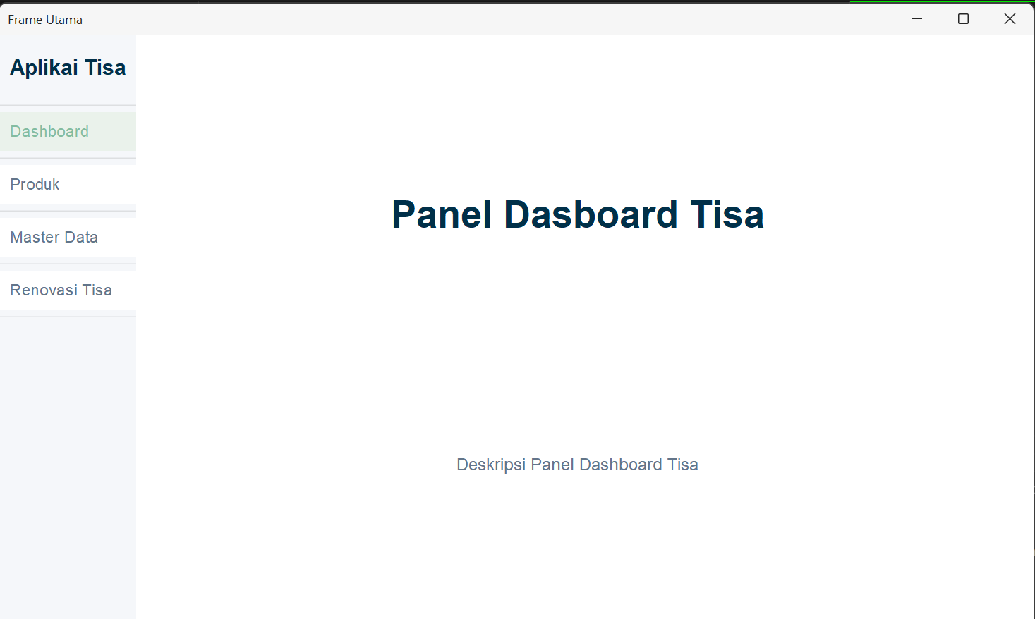
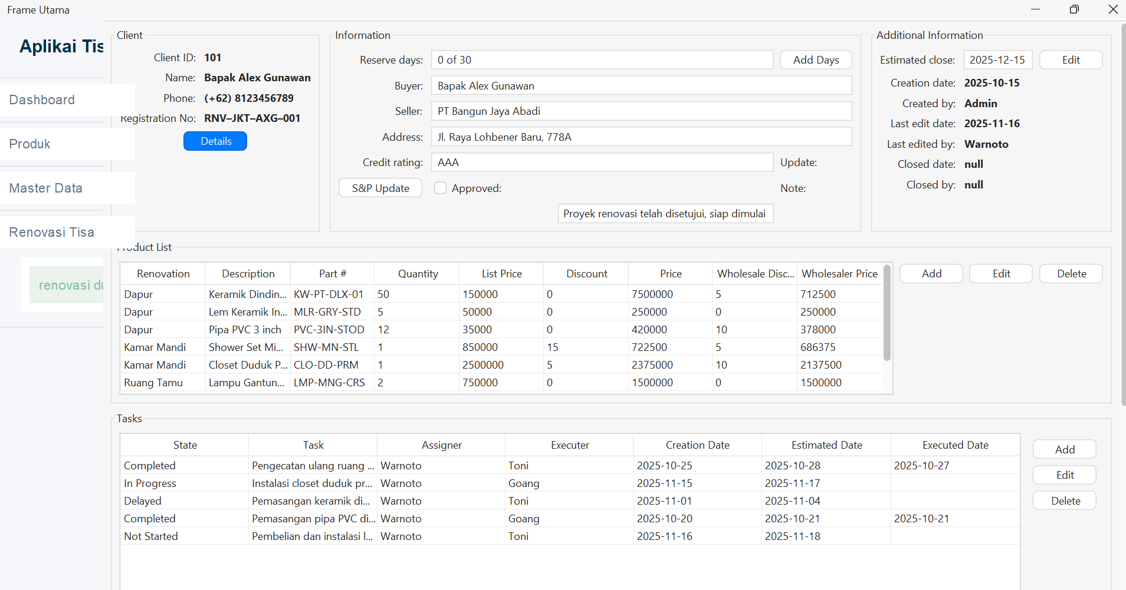
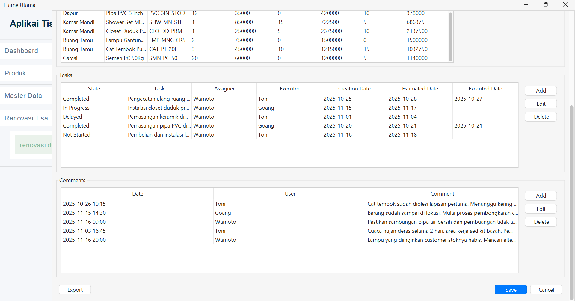

Pengalaman Pembelajaran
Dalam pemahaman lumayan faham, namun agak kesulitan dalam pengerjaan tugas, dikarenakan terbatasnya alat (berupa laptop). Sehingga dalam pengerjaan nya kurang sempurna.

